COS80022 – Software Quality and Testing

Test Report for Lab 6

Student Name: Arun Ragavendhar Arunachalam Palaniyappan
Student ID: 104837257
Student email: 104837257@student.swin.edu.au
Submission date: 14/04/2024

- Test Cases

The below list of test cases were the ones executed in lab 4 after checking for all conditions.
The idea here is to use these test cases to run test scripts on

# | Input Data | Expected Result (Oracle) | Actual Output(log)
TC1 | 3,4,5 | “scalene Triangle” | “scalene Triangle”
TC2 | 7,7,7 | “equilateral triangle” | “equilateral triangle”
TC3 | 12,14,30 | “invalid entry-the sides do not form a triangle” | “invalid entry-the sides do not form a triangle”
TC4 | 14,12,30 | “invalid entry-the sides do not form a triangle” | “invalid entry-the sides do not form a triangle”
TC5 | 30,12,14 | “invalid entry-the sides do not form a triangle” | “invalid entry-the sides do not form a triangle”
TC6 | 2,2,10 | “invalid entry-the sides do not form a triangle” | “invalid entry-the sides do not form a triangle”
TC7 | 5,-3,5 | “invalid entry-enter a positive integer” | “invalid entry-enter a positive integer”
TC8 | 8,0,0 | “invalid entry-enter a positive integer” | “invalid entry-enter a positive integer”
TC9 | 0,0,0 | “invalid entry-enter a positive integer” | “invalid entry-enter a positive integer”
TC10 | 9,9,15 | “isosceles triangle” | “isosceles triangle”
TC11 | 9,15,9 | “isocelos triangle” | “isosceles triangle”
TC12 | 15,9,9 | “isocelos triangle” | “isosceles triangle”
TC13 | 3,5,0 | “invalid entry-enter a positive integer” | “invalid entry-enter a positive integer”
TC14 | 3,4,7 | “invalid entry-the sides do not form a triangle” | “invalid entry-the sides do not form a triangle”
TC15 | 7,3,4 | “invalid entry-the sides do not form a triangle” | “invalid entry-the sides do not form a triangle”
TC16 | 7,4,3 | “invalid entry-the sides do not form a triangle” | “invalid entry-the sides do not form a triangle”
TC17 | 6.2,4.4,8.1 | “a=int(input())  ^^^^^^^^^^^^  ValueError: invalid literal for int() with base 10: '6.2,4,4,8.1’ | a=int(input())  ^^^^^^^^^^^^  ValueError: invalid literal for int() with base 10: ''6.2,4,4,8.1’
TC18 | 4,8 | c=int(input())  ^^^^^^^^^^^^  ValueError: invalid literal for int() with base 10: ' ' | c=int(input())  ^^^^^^^^^^^^  ValueError: invalid literal for int() with base 10: ' '

- Test Results

Test scripts written for the test cases and they were run and executed and the output has been noted down. In some test cases expected output has not come, so let us debug the main program and retry again.

# | Input Data | Expected Result (Oracle) | Actual Output(log)
TC1 | 3,4,5 | “scalene” | “scalene”
TC2 | 7,7,7 | “equilateral” | “equilateral”
TC3 | 12,14,30 | "Not a triangle! the sum of two sides should be larger than the third!" | "Not a triangle! the sum of two sides should be larger than the third!"
TC4 | 14,12,30 | "Not a triangle! the sum of two sides should be larger than the third!" | "Not a triangle! the sum of two sides should be larger than the third!"
TC5 | 30,12,14 | "Not a triangle! the sum of two sides should be larger than the third!" | "Not a triangle! the sum of two sides should be larger than the third!"
TC6 | 2,2,10 | "Not a triangle! the sum of two sides should be larger than the third!" | "Not a triangle! the sum of two sides should be larger than the third!"
TC7 | 5,-3,5 | "Invalid input! You should provide positive integers!" | "Invalid input! You should provide positive integers!"
TC8 | 8,0,0 | "Invalid input! You should provide positive integers!" | "Invalid input! You should provide positive integers!"
TC9 | 0,0,0 | "Invalid input! You should provide positive integers!" | "Invalid input! You should provide positive integers!"
TC10 | 9,9,15 | “isosceles” | “scalene”
TC11 | 9,15,9 | “isosceles” | “isosceles”
TC12 | 15,9,9 | “isosceles” | “isosceles”
TC13 | 3,5,0 | "Invalid input! You should provide positive integers!" | "Invalid input! You should provide positive integers!"
TC14 | 3,4,7 | "Not a triangle! the sum of two sides should be larger than the third!" | "Not a triangle! the sum of two sides should be larger than the third!"
TC15 | 7,3,4 | "Not a triangle! the sum of two sides should be larger than the third!" | "Not a triangle! the sum of two sides should be larger than the third!"
TC16 | 7,4,3 | "Not a triangle! the sum of two sides should be larger than the third!" | "Not a triangle! the sum of two sides should be larger than the third!"
TC17 | 6.2,4.4,8.1 | "Invalid input! You should provide integers!" | "Invalid input! You should provide integers!"
TC18 | 4,8 | "Invalid input! You should provide three numbers!" | "Invalid input! You should provide three numbers!"

Screenshot
Test scripts were written to run the above 18 test cases to cover all the scenarios and the when the test script file was run, the below result was obtained.
Failed test case:
TC10 | 9,9,15 | “isosceles” | “scalene”

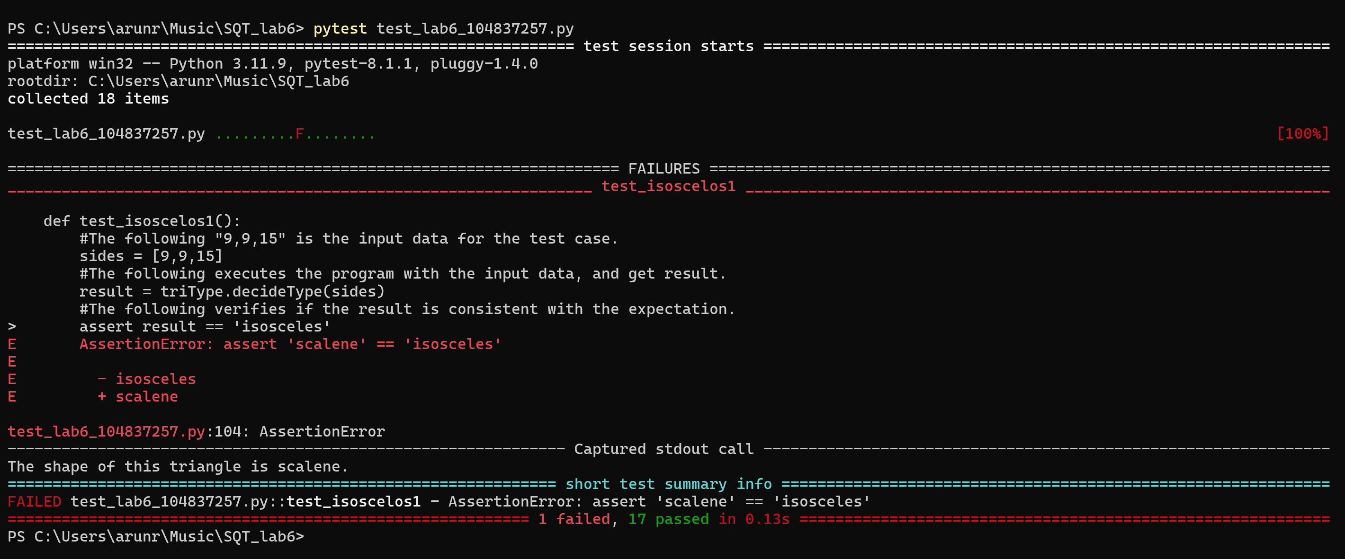

Analysis of results
On analysing the test outputs, a bug in the source code of the triType.py file was found.
if a != b:
if b == c:
shape = "isosceles"
else:
if a == c:
shape = "isosceles"
else:
shape = "scalene"
else:
if b == c:
shape = "equilateral"
else:
shape = "scalene"

There is an error in this code in the last else block.
That particular else block will be executed when
a==b and b! =c
so, if the control flow enters that else block, it should actually be an “isosceles”, but is wrongly marked as a “scalene”

Corrected code:

f a != b:
if b == c:
shape = "isosceles"
else:
if a == c:
shape = "isosceles"
else:
shape = "scalene"
else:
if b == c:
shape = "equilateral"
else:
shape = "isosceles"

After the code correction, the test script file was run again and this time all 18 test cases passed the test.

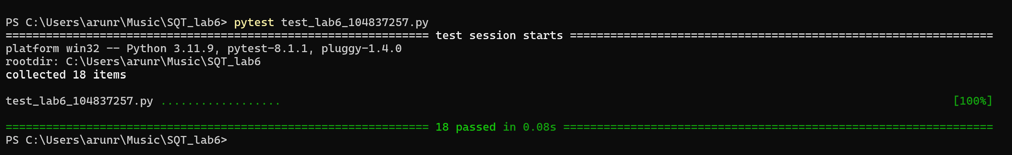

Hence, testing has been successfully implemented to debug a program.

